**Badge CTF Starting Point**

**If you see this symbol, it is part of the Badge CTF**

**Lockpicking Village**

**Hardware Hacking Village** 

**RF Village** 

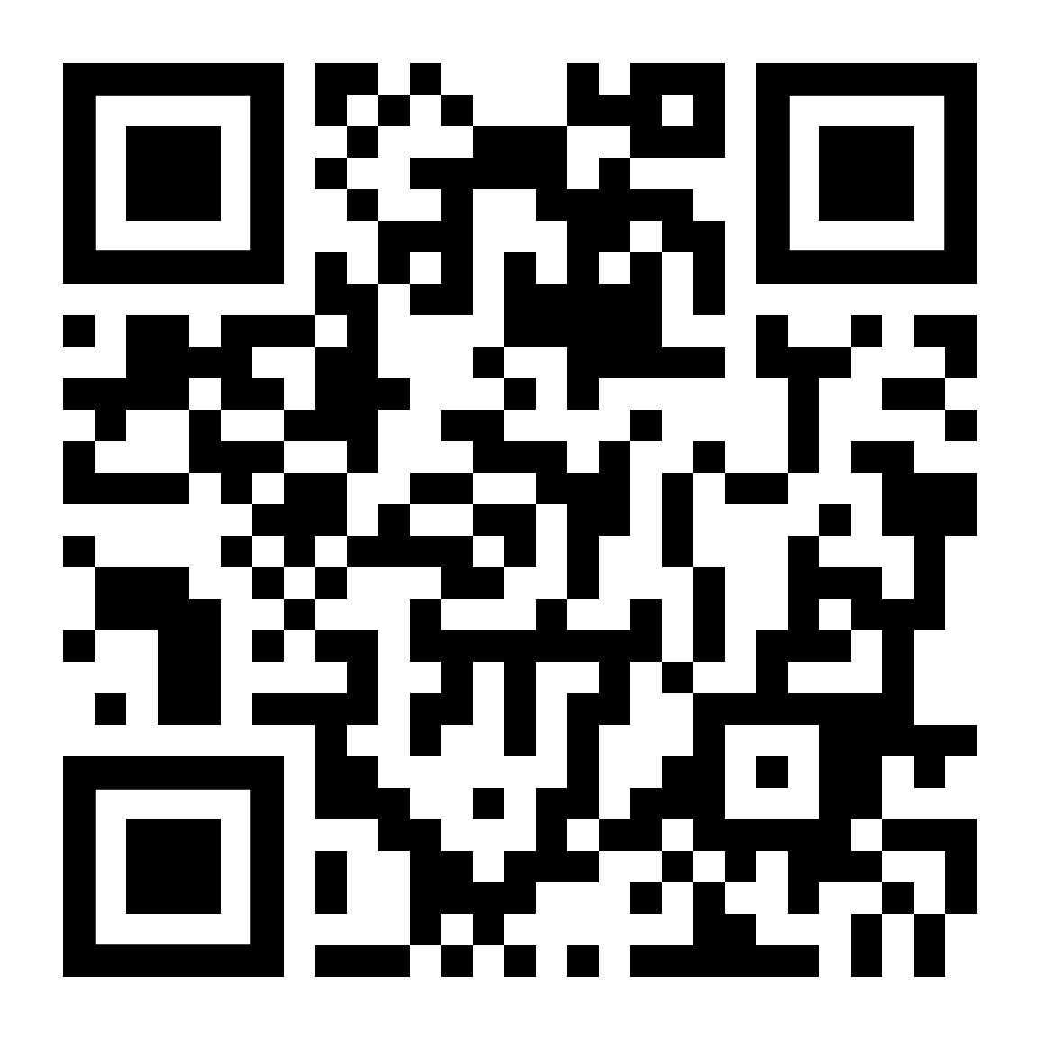**Scavenger Hunt**